Homophones (Proper)

🔹 What Are Homophones (Proper)
# Source: Chatgpt (GPT-4-turbo) at [8/1/2025]
Homophones (proper) are true homophones: words that are pronounced the same but are spelled differently and have completely different meanings.
They are the "classic" homophones—what people usually mean when they say “homophones.”

🧱 Key Features of Homophones (Proper)
# Source: Chatgpt (GPT-4-turbo) at [8/1/2025]
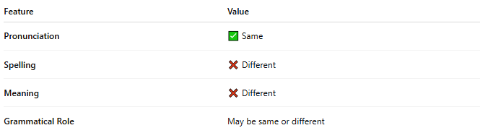
Feature | Value
Pronunciation | ✅ Same
Spelling | ❌ Different
Meaning | ❌ Different
Grammatical Role | May be same or different

📝 Examples of Homophones (Proper)
# Source: Chatgpt (GPT-4-turbo) at [8/1/2025]
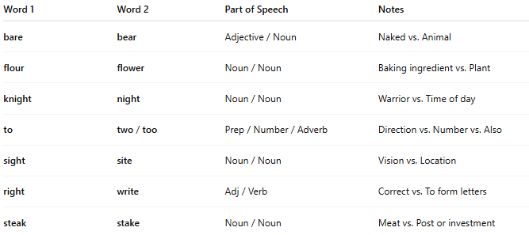
Word 1 | Word 2 | Part of Speech | Notes
bare | bear | Adjective / Noun | Naked vs. Animal
flour | flower | Noun / Noun | Baking ingredient vs. Plant
knight | night | Noun / Noun | Warrior vs. Time of day
to | two / too | Prep / Number / Adverb | Direction vs. Number vs. Also
sight | site | Noun / Noun | Vision vs. Location
right | write | Adj / Verb | Correct vs. To form letters
steak | stake | Noun / Noun | Meat vs. Post or investment

🎯 Common Uses
# Source: Chatgpt (GPT-4-turbo) at [8/1/2025]
- Wordplay (puns, jokes)
- Confusing pairs in spelling and grammar
- Rhyme in poetry and song (e.g., "bare" rhyming with "bear")
- Homophone-based riddles (e.g., “What has four wheels and flies?” → A garbage truck)

🔍 How to Identify Homophones (Proper)
# Source: Chatgpt (GPT-4-turbo) at [8/1/2025]
Ask:
✅ Do they sound the same?
❌ Are they spelled the same?
❌ Do they mean the same thing?
If YES to first and NO to the rest → They are homophones (proper).

🧭 Comparison with Related Terms
# Source: Chatgpt (GPT-4-turbo) at [8/1/2025]
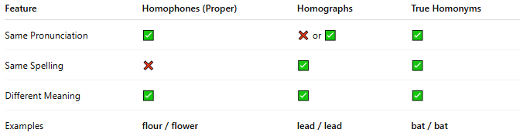
Feature | Homophones (Proper) | Homographs | True Homonyms
Same Pronunciation | ✅ | ❌ or ✅ | ✅
Same Spelling | ❌ | ✅ | ✅
Different Meaning | ✅ | ✅ | ✅
Examples | flour / flower | lead / lead | bat / bat

